PARTS OF THE LEAF

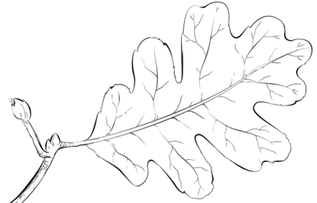  PETIOLE | MARGIN | BLADE
VEINS | MIDRIB | STIPULE

PARTS OF THE LEAF

PETIOLE | MARGIN | BLADE
VEINS | MILDRIB | STIPULE

